**PROCESS INSTRUMENTATION**

**Name: Vivek Chandrashekhar Rugale**

**GR No.: 11810369**

**Div.: TY-C**

**Roll No.: 24 (Batch B1)**

**LAB 4:**

**Aim - Study the working modes of Alarm Annunciator and design and implement the alarm annunciator logic.**

Alarm Annunciator – Manual Reset 1 mode logic implementation in Codesys software:

Ladder Diagram:

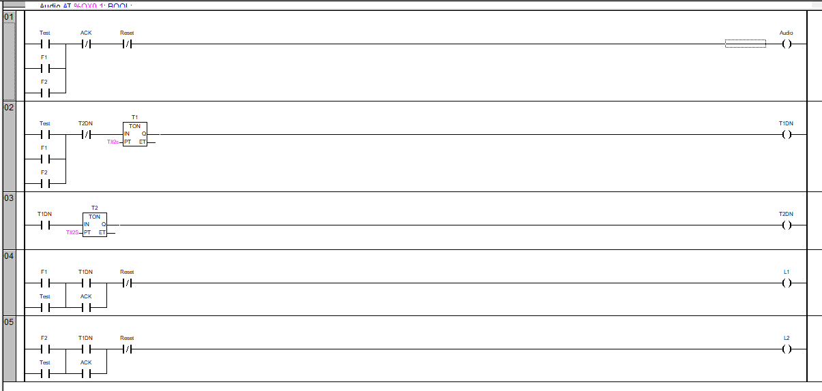

While Running:

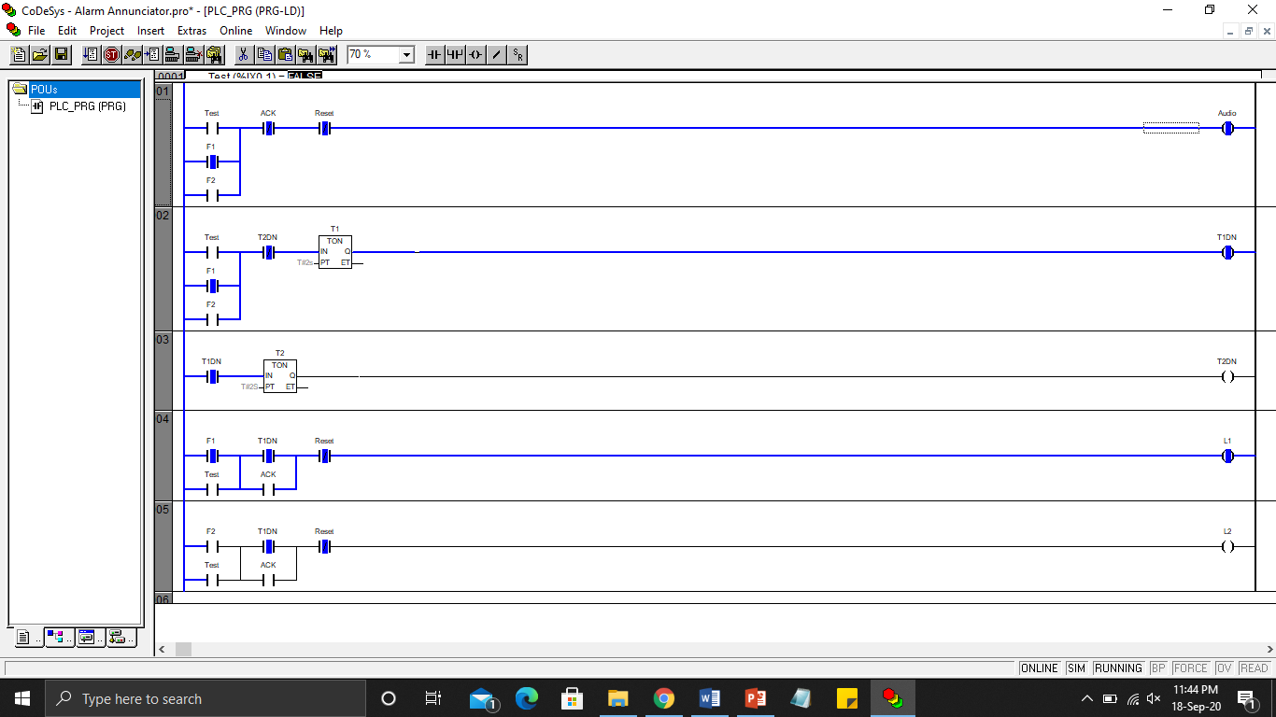

**Conclusion:** Studied the working of different modes of an alarm annunciator. Implemented the logic of manual reset-1 mode of alarm annunciator in codesys software. When a fault occurs audio becomes on and flashing of light starts for that particular fault LED with the frequency of 2 seconds. Audio becomes off after acknowledgement from the operator and everything is reset when the operator presses the reset pushbutton.